Mid-Holocene South Cherpuk monogenetic volcanic center of Ichinskaya zone (Sredinny Ridge, Kamchatka): some petrological features of rocks and first data on the melt’s composition.

Anna O. Volynets*, Pavel U. Pletchov*, Maria M. Pevzner**
*Department of Geology, Moscow State University, Leninskie hills, 1, 119234 Moscow, Russia, Tel. (7 095) 939 18 41, E-mail: volynetka@pisem.net
**Geological Institute, Pyzhevsky per., 7, 109017, Moscow, Russia
Tel.: (7 095) 230 8104; FAX: (7 095) 953 0760; E-mail: suler@geo.tv-sign.ru

The study of Pleistocene-Holocene Ichinsky volcano (Sredinny Ridge of Kamchatka) and associated monogenetic lava field is very interesting and actual because:
1. Targets are situated in the rear part of the Kamchatka volcanic arc - in fact 200 km behind the volcanic front. Nevertheless, the volcano and lava fields are active: last eruptions of Ichinsky occurred within the last 1800 years (possibly even few hundred years ago) and last eruptions of the monogenetic cones South and North Cherpuk took place approximately 6500 ¹⁴C years B.P. Fumaroles near Ichinsky summit are still active.
2. Specific geochemical composition compare to volcanic front lavas. Previous study of the geochemistry of the Kamchatka lava fields has shown that while most basalts of monogenetic lava fields all over Kamchatka demonstrate notable similarity, those of Ichinskaya zone differ dramatically and exhibit some features untypical for island arc volcanics. Studies of Churikova et al. (2001) have allowed them to identify OIB-component in the mantle source of Sredinny Ridge region (co-called basalts of within-plate type).
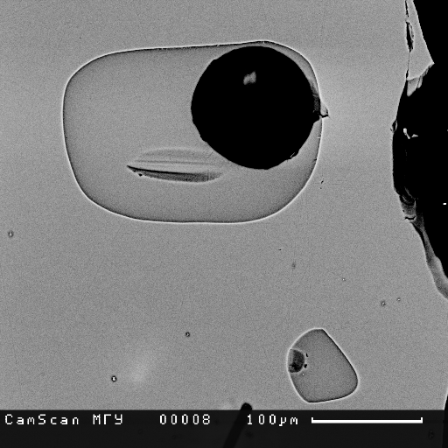
We selected the South Cherpuk samples because we observed there a lot of primary glassy inclusions during petrographic study. Here we present first results of study of spinel and melt inclusions in olivines from South Cherpuk lavas. South Cherpuk is a monogenetic cone with extensive lava flow situated 21 km southwest of Ichinsky volcano. Products of the cinder cone and lava flow are presented by olivine basalts. The amount of phenocrysts is about 15%, olivine dominates, phenocrysts of plagioclase and clinopyroxene are presented in a smaller amount. Groundmass consists of clinopyroxene, olivine, plagioclase, titanomagnetite and volcanic glass. Two samples from lava flow were studied for olivine compositions. Samples were taken at the southern, earliest portion of the lava flow, and at the western portion of the lava flow. Olivine is Fo75-84, Fo80-81 sharply prevail. Ore mineral, included in the olivine, is presented by cromian spinel. Cr/Cr+Al varies in a short range from 0.52 to 0.56. These values are corresponds to harzburgite mantle beneath and mantle melting degree near 20-25% (Pearce et al, 2000). Calculated by olivine-spinel equilibrium (Ballhaus et al., 1991) oxygen fugacity for these magmas is NNO-NNO+1 and it is usual redox conditions for island arc magmas. Substantial part of melt inclusions has clinopyroxene and spinel daughter phases. There is as well a large amount of glassy inclusions (fig.1), have been found in the sample 201124, from the western part of the lava flow. Melt inclusions and host olivines were analyzed on EPMA in Moscow University. Measured compositions of glasses were corrected to host olivine crystallization (in average, 9.5 wt.% of olivine was crystallized to the cavity walls in the sample 201124) and to Fe-loss effect by Danyushevsky model (Danyushevsky, 2000).
Fig. 1 Glassy melt inclusions in olivine, sample 201214. 1sm=10⁻⁶m.
Whole rocks and melt inclusions from South Cherpuk show generally the same composition. On the discrimination diagram SiO₂-K₂O figurative points of melts are situated within the bounds of general trend of the most whole-rock analyses of Ichinsky volcano and monogenetic field rocks (fig.2). They lie at the boundary of the high-K and medium-K rocks. Such closeness of the compositions could indicate that rocks produced by South Cherpuk monogenetic cone are rather close to initial magmas and haven’t undergo fractionation substantially. Analyzed melt inclusions contain comparatively large amount of volatile elements, like S (up to 0.7 wt.%), P (up to 0.65 wt.%) and relatively small chlorine content (less then 0.1 wt.%). The most magnesian melts (with lower contents of SiO₂) are the most volatile-rich. It can show that magma was degassed during its upraise. The big bubbles in the inclusions (fig.1) could be another indirect proof (Frezzotti, 2001) of the volatile enrichment of magma. Calculated temperature by (Ford, 1983) for the olivine crystallizing is 1152±15ºC.
Fig. 2 K₂O (wt%) vs SiO₂ (wt%) in rocks of Ichinsky volcano and surrounding monogenetic centers (squares for middle-upper Pleistocene, triangles for holocene centers and small black circles for South Cherpuk lava) and melt inclusions in olivine (big circles) from South Cherpuk lava, sample 201124. Whole rock data are from published sources. Classification lines by Gill, 1981.

Ballhaus, C., R.F. Berry, and D.H. Green, High pressure experimental calibration of the olivine-orthopyroxene-spinel oxygen geobarometer: implications for the oxidation state of the upper mantle // Contributions to Mineralogy and Petrology, 1991. 107: p. 27-40.
Churikova, T., Dorendorf, F., Woerner, G. Sources and fluids in the mantle wedge below Kamchatka, evidence from across-arc geochemical variation. // Journal of Petrology, 2001, v. 42, N 8, p. 1567-1593.
Danyushevsky, L.V., F.N. Della-Pasqua, and S. Sokolov, Re-equilibration of melt inclusions trapped by magnesian olivine phenocrysts from subduction-related magmas: petrological implications. Contributions to Mineralogy & Petrology, 2000. 138(1): p. 68-83.
Ford, C.E., Russel, D.G.,Graven, J.A.,Fisk, M.R, Olivine-liquid equilibria: temperature, pressure and composition dependence of the crystal/liquid cation partition coefficients for Mg, Fe²⁺, Ca and Mn // Journal of Petrology, 1983. 24: p. 256-265.
Frezzotti, M.L., Silicate-melt inclusions in magmatic rocks: applications to petrology// Lithos, 2001. 55(1-4): p. 273-299.
Gill, J.B., Orogenic andesites and plate tectonics // Berlin-Heidelberg: Springer-Verlag, 1981, p.390.
Gramenitsky E.N., Kotel’nikov A.R., Batanova A.M., Schekina T.I., Pletchov P.Yu. Experimental and technical petrology // “Nauchniy Mir”, Moscow 2000, 415, in Russain
Pearce, J.A., et al., Geochemistry and tectonic significance of peridotites from the South Sandwich arc-basin system, South Atlantic // Contributions to Mineralogy & Petrology, 2000. 139(1): p. 36-53.

