Melt inclusion synthesis in alkaline feldspars of Q-Ab-Or system.
Trusov S.V., Pletchov P.Yu. and Kotelnikov A.R.

The aim of this work was a melt inclusion synthesis during the process of new phase growth on similar composition natural crystals. Inclusions were trapped with subhedral growing of crystal single blocks or within-growing crystal rims. The synthesis of melt inclusions was carried on with the alkaline feldspar growth in the subliquidus area of the granit system under gradually temperature decreasing. Mixture composition corresponded to feldspar liquid-solid equilibrium under temperature 780ºC (Q - 20%, Ab – 56%, Or - 24%).
Grains of natural Or(fraction 0,5-1 mm) were used as a nuclear centers for crystal growth. Mix with grains of natural Or were heated to 810ºC (approximately by 50ºC higher than the liquidus temperature) and exposed under these conditions for 4 hours (until complete melting and homogenization of mix). Then the temperature was reduced to subliquidus during next 6 days with decreasing rate 10 º per day.
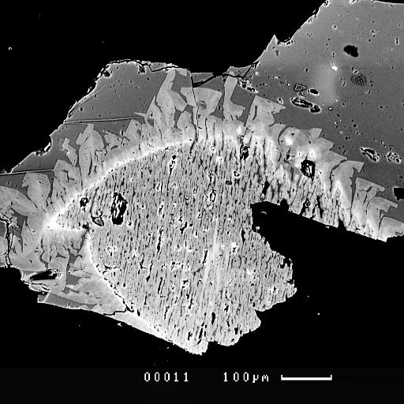
Fig.1
There are particularly melting and strongly rezorbed grains of Or, which overgrown by new-formed alkaline feldspar (fig.1). New formations of feldspar are presented by block crystal with radial direction to large Or crystals. Via step-by-step temperature decreasing, crystals have got clear expressed composition zones. Later (outer) zones are enriched by Na and depleted by K to compare with earlier (inner) zones of new-formed alkaline feldspar.
Fig. 2 shows chemical analyses of experimental products. Compositions of artificial melt inclusions are situated on the cotectic line or above it (in the Q field). Trapping of inclusions took place in the feldspar crystallization field. Composition of capturing melt is situated on the line, which connected feldspar composition to initial mixture composition. Such effect is for feldspar crystallization to the inclusion walls. That's why some compositions of glass inclusions, which was captured in the feldspar
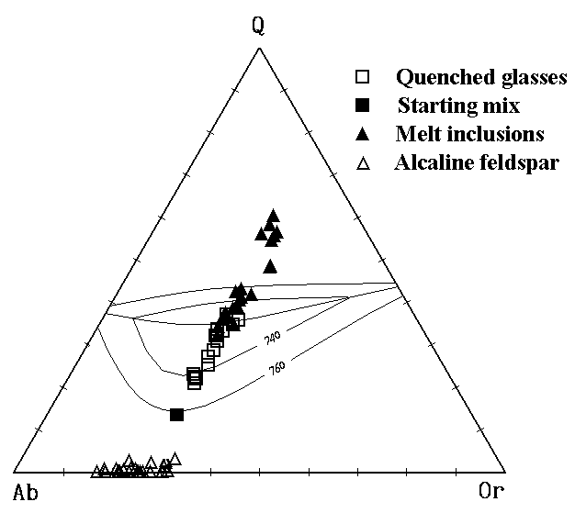
Fig.2
field, is situated on the cotectic line. The other inclusion compositions are situated in the crystallization field of Q. Such effect can be described by further feldspar growth, after the system comes to the cotectic. Q can't crystallize because one hasn’t nucleation centers.
Thus, we showed the principal possibility of the melt inclusions synthesis in the process of new-formation growth on nuclear centers. This method is easier than crack-forming synthesis methods [2]. It allows one to observe the evolution of melt composition by study of melt inclusion compositions in the different new-formed zones.
This work was supported by the Russian Foundation for Basic Research, Project no. 96-05-64911
References:
- Johannes W., Holtz F., (1996) Petrogenesis and experimental petrology of granitic rocks. Springer-Verland Berlin-Heidelberg. 335p.
- Pletchov P.Yu., Gramenitskii E. N., Kotelnikov A. R. (1999) Synthesis of melt inclusions in haplogranit system. Dokladi Akademii Nauk, N1 pp. ??.

